Xylene

The three isomeric xylenes (isomeric means that they have exactly the same number and kind of atoms but are arranged differently) occur together, and with them is another isomer, ethylbenzene, which has one ethyl group (―C2H5) replacing one of the hydrogen atoms of benzene. These isomers can be separated only with difficulty, but numerous separation methods have been worked out. The small letters o-, m-, and p- (standing for ortho-, meta-, and para-) preceding the name xylene are used to identify the three different isomers that vary in the ways the two methyl groups displace the hydrogen atoms of benzene.

**Ortho-xylene**

is used mostly to produce phthalic anhydride, an important intermediate that leads principally to various coatings and plastics.

ORTHO-XYLENE -TDS (DOWNLOAD LINK)

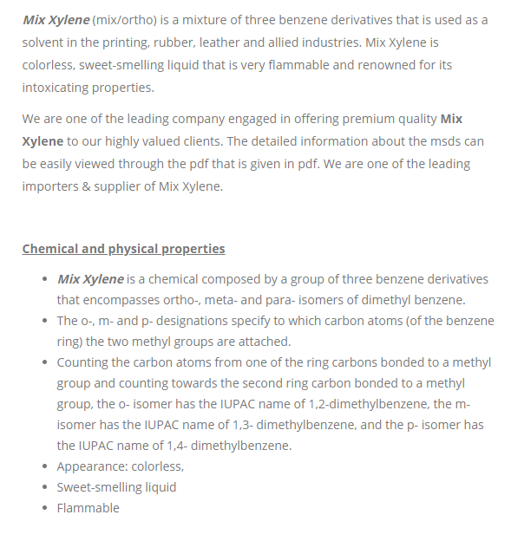MIX XYLENE